**Q1. Find the roots of the following equation and plot the graph.**

$$x^{2} – 5x + 6 = 0$$

**Script Code:**

|  |
| --- |
| clc, clear  %Finding Roots of the Equation  %Q1# x^2 - 5x + 6 = 0    f = [1 -5 6];  root_f = roots(f)    %%  x = 0:0.2:5;  y = x.^2 - 5*x + 6;    %Plotting of the Function    plot(x,y, 'r--');  hold on; %Used for scatter function  title('Kamil Siddiqui - Root Finding Lab2 Q1')  xlabel('X - Axis')  ylabel('Y - Axis')  xlim([0 5]), ylim([-1 3]);  line([0 5], [0 0])  line([0 0], [-1 3])    %Pointing the roots on graph  scatter(root_f, [0 0], 'ks'); |

**Results:**

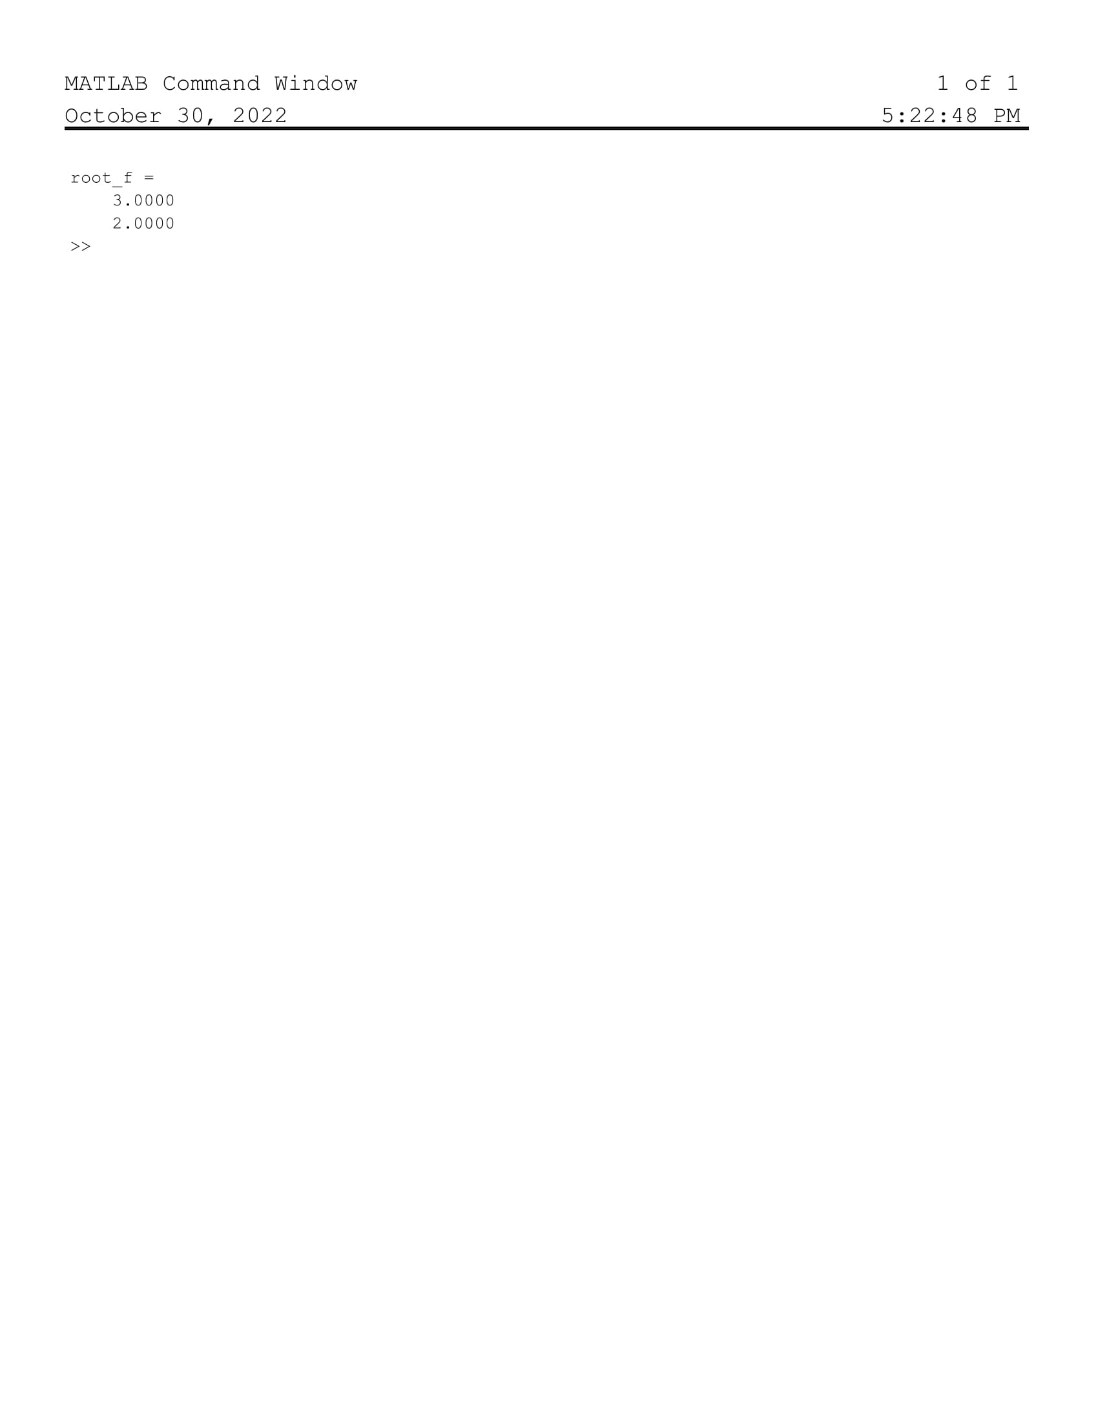

**Graph:**

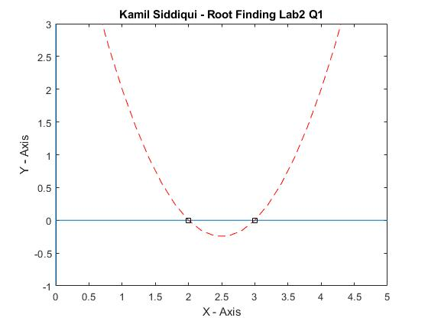

**Q2. Find the roots of the following equation and plot the graph.**

$$x^{2} – 9x + 8 = 0$$

**Script Code:**

|  |
| --- |
| clc, clear  %Finding Roots of the Equation  %Q2# x^2 - 9x + 8 = 0    f = [1 -9 8];  root_f = roots(f)    %%  x = -1:0.2:10;  y = x.^2 - 9*x + 8;    %Plotting of the Function    plot(x,y, 'r--');  hold on; %Used for scatter function  title('Kamil Siddiqui - Root Finding Lab2 Q2')  xlabel('X - Axis')  ylabel('Y - Axis')  xlim([-1 10]), ylim([-15 15]);  line([-1 10], [0 0])  line([0 0], [15 -15])    %Pointing the roots on graph  scatter(root_f, [0 0], 'ks'); |

**Results:**

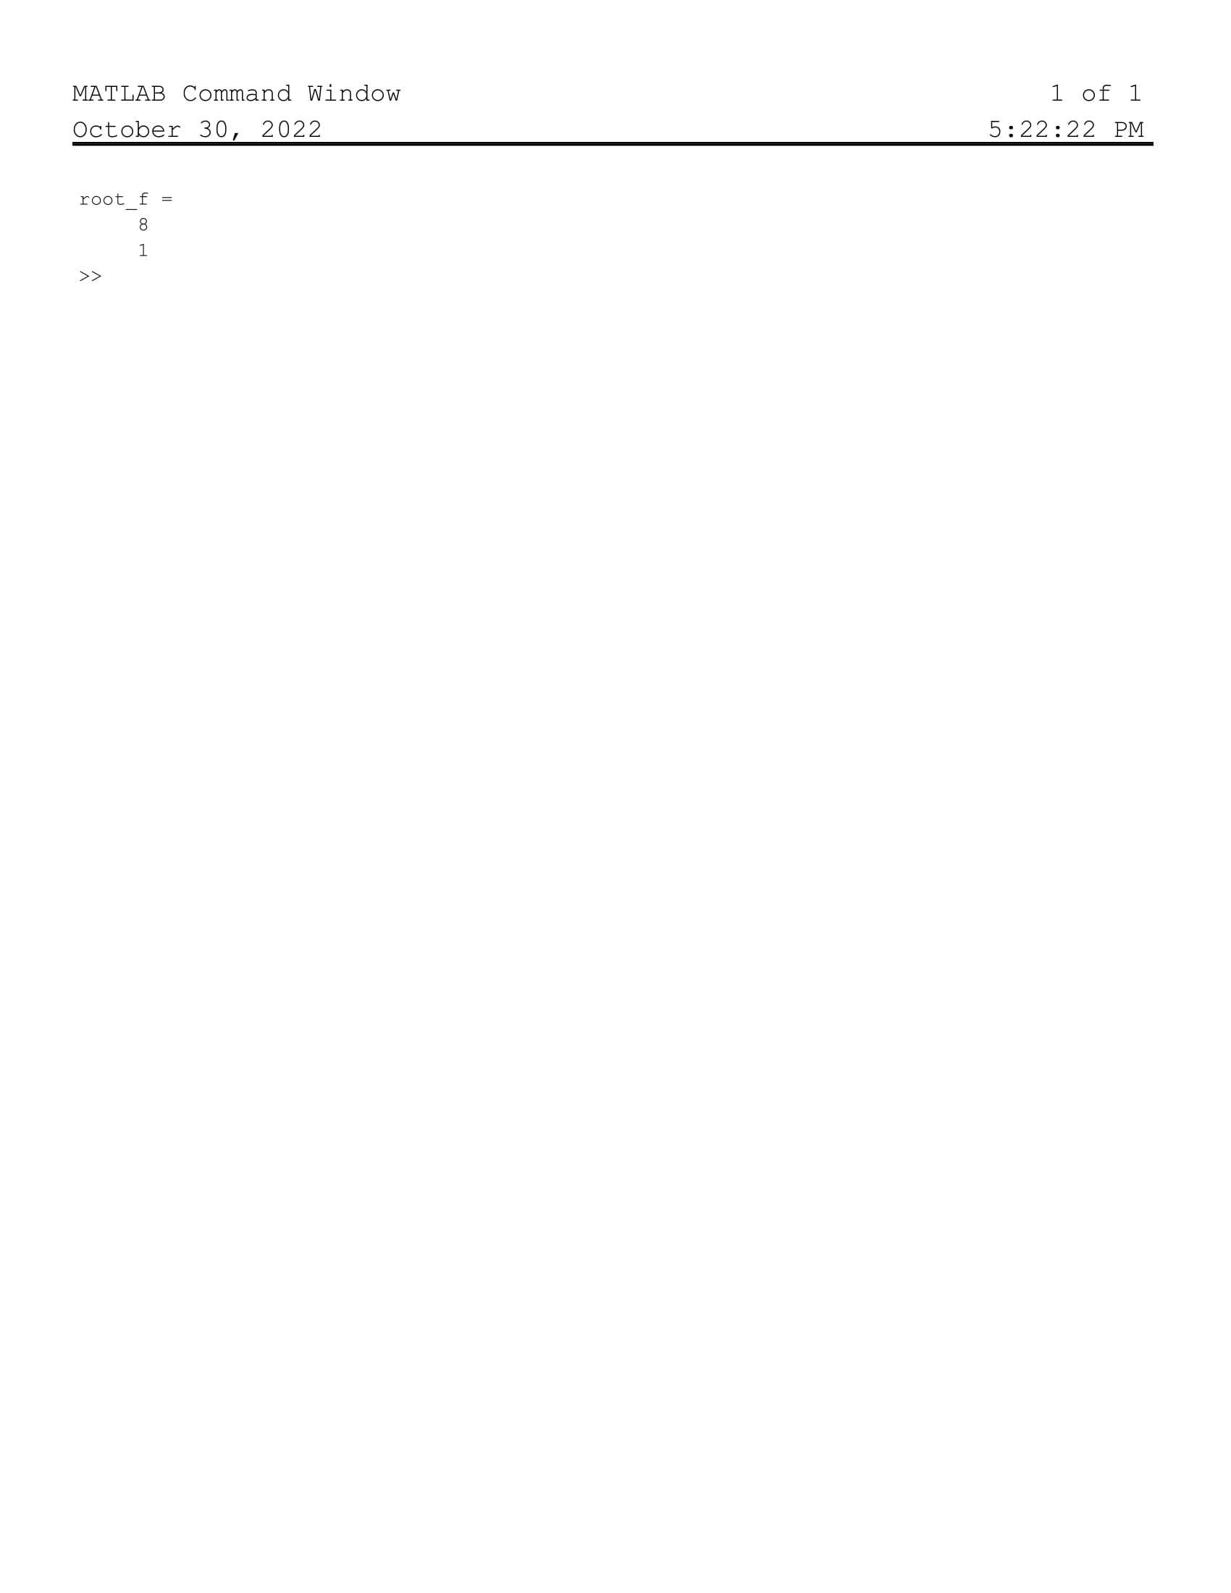

**Graph:**

